ACSL
American Computer Science League
2013 - 2014

Contest #1

Classroom Division Page 1

1. Recursive Function
Find (9) given:
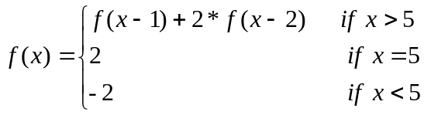

- Recursive Functions
Find (8,14) given:
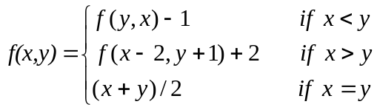
3. Computer Number Systems
Which is the largest?
F1₁₆, 375₈, 10F₁₆, 264₁₀, 11111000₂

4. Computer Number Systems
Simplify the following and convert answer to binary.
101₂ * 3₁₀ + 11₁₆ – 52₈ / 6₁₀

- What Does This Program Do?
What is printed when this program is run?
a = 100: b = 10: c = 5: d = 4: e = 2
if b * c > c * d then b = c * d else c = b * c
if a / b = b / d then a = a / b else b = b * d
if a+d > b/e then e = d*e else d = d/e
if a * e > c ^ e then b = a - e else c = b - c
print a + b * c – d / e
end

